Software requirement specification

E-commerce management system

**SUBMITTED BY,**

M Karthik (4NM20CM017)

**SUBMITTED TO**

Chidananda T

NMAMIT NITTE

**SUBMISSION DATE**

26/06/2022

INDEX :

**1) INTRODUCTION**

1.1 SCOPE

1.2 OVERVIEW

**2) SPECIFIC REQUIREMENTS**

2.1 FUNCTIONAL REQUIREMENTS

2.2 NON-FUNCTIONAL REQUIREMENTS

2.3 PERFORMANCE REQUIREMENTS

**3) ARCHITECTURAL DESIGN**

3.1 ACTIVITY DIAGRAM

3.2 SEQUENCE DIAGRAM

3.3 USE CASE DIAGRAM

3.4 CLASS DIAGRAM

**4) CONCLUSION**

**Introduction**

This project aims to create an E-commerce website to provide a satisfying consumer and seller experience. This document will describe the first version of the document. The SRS aims to cover the entire scope of the project.  In this modern fast-paced and busy world, E-commerce platforms provide a very convenient way for people across the world to get their desired products at their doorstep. Hence, E-commerce platforms must be fast, convenient and efficient to cater to the needs of both the buyer and seller.

**SCOPE**

This software is an e-commerce platform which helps customers to make effective purchases and helps sellers in increasing the sales and management of their products. Each customer and seller have access to pages where they can organize and see all their records. There are options to optimize search and keep track of the products one likes. There are methods designed to accept payment. There is a portal for customer support too in case of any discrepancies.

**OVERVIEW**

This system provides an easy solution for customers to buy the product without going to the shop and to shop owner to sale the product. This proposed system can be used by any naive users, and it does not require any educational level, experience or technical expertise in computer field but it will be of good use if user has the good knowledge of how to operate a computer.

**SPECIFIC REQUIREMENTS**

In this e-commerce system the consumers can browse through the shops and choose their desired products to place in a virtual shopping cart. The shopping cart details (Such as Product, Quantity, Shipping Address, etc) can be viewed, and items can be removed from the cart. To proceed with the purchase, the customer needs to log in. There will be an option for creating an account. Also, the customer can modify personal profile information (such as phone number, email address, and shipping address) which is stored by the application. The consumers can also view the status of any previous orders and cancel orders that have not been shipped yet. And there will be a payment gateway to payment.

**Functional Requirements:**

This section provides requirement overview of the system. Various functional modules that can be implemented by the system will be-

Description: Registration If customer wants to buy the product then he/she must be registered, unregistered user can’t go to the shopping cart. Login Customer logins to the system by entering valid user id and password for the shopping. Changes to Cart Changes to cart means the customer after login or registration can make order or cancel order of the product from the shopping cart. Payment In this system we are dealing the mode of payment by Cash. We will extend this to credit card, debit card etc in the future. Logout After ordering or surfing for the product customer has to logout. Report Generation After ordering for the product, the system will sent one copy of the bill to the customer’s Email-address and another one for the system data base.

**Non-Functional Requirements**:

Following Non-Functional Requirements will be there:

* Secure access to consumer’s confidential data.
* 24X7 availability.
* Better component design to get better performance at peak time.
* Flexible service-based architecture will be highly desirable for future extension.
* Non-Functional Requirements define system properties and constraints.

Non-Functional Requirements are:

* Security
* Reliability
* Maintainability
* Portability
* Extensibility
* Reusability
* Compatibility
* Resource

**Performance Requirements**:

In order to maintain an acceptable speed at maximum number of uploads allowed from a particular customer as any number of users can access to the system at any time. Also, the connections to the servers will be based on the attributes of the user like his location and server will be working 24X7 times.

**ACRHITECTURAL DESIGN:**

**ACTIVITY DIAGRAM**

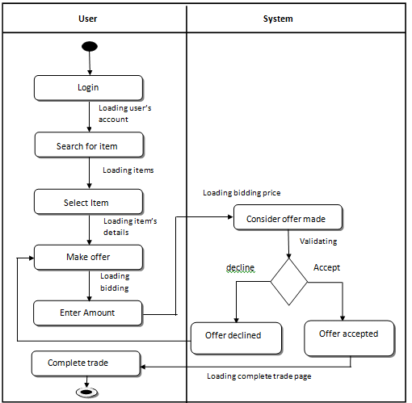

**SEQUENCE DIAGRAM**

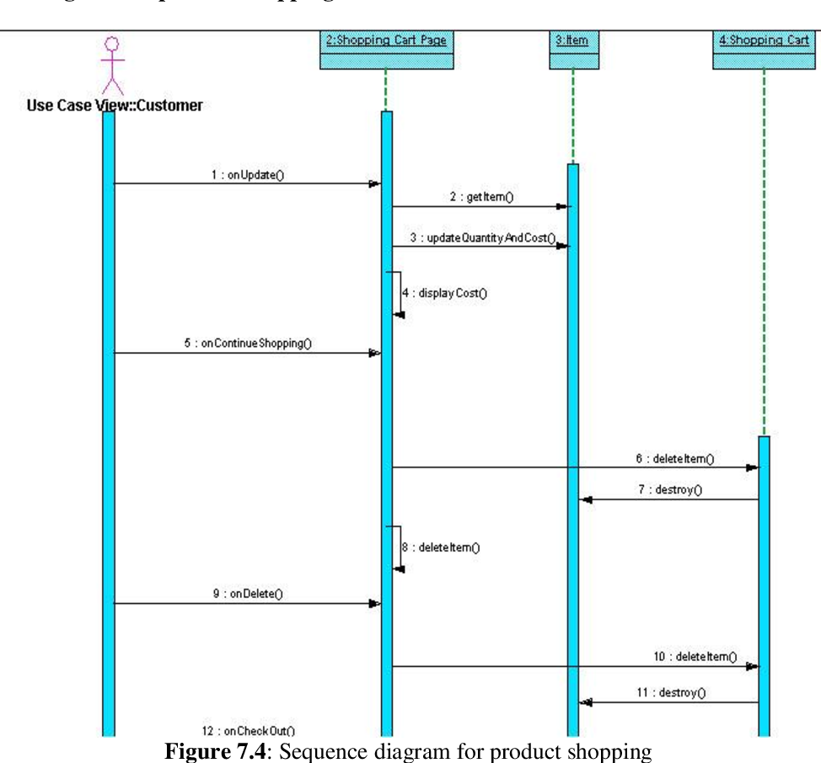

**USE CASE DIAGRAM**

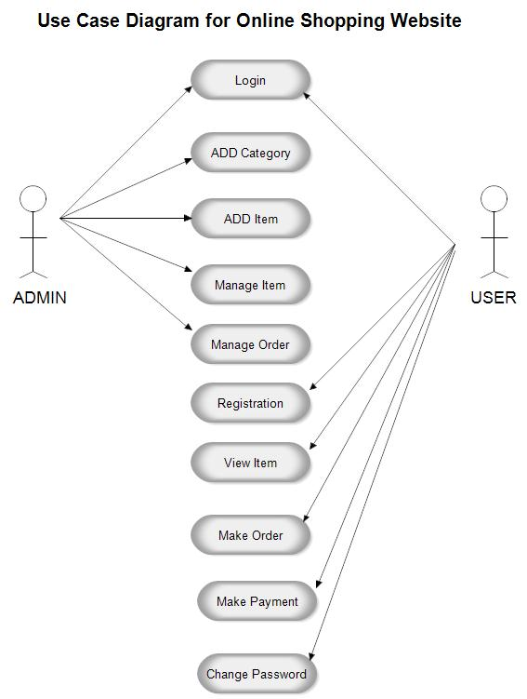

**CLASS DIAGRAM**

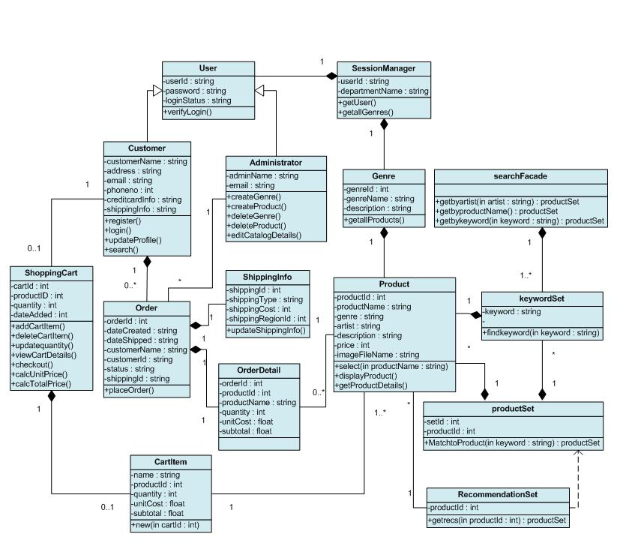

**CONCLUSION**

 E-commerce still represents one of the business methods that take advantage if done the right way, even if the stock market and commodities fell, but E-Commerce still able to survive and receive high transaction. In addition, it is also to introducing new techniques and styles in a transaction. Use the extensive E-Commerce in the Internet world is much better to bring the goodness of the individual or the state. E-Commerce has undeniably become an important part of our society. The successful companies of the future will be those that take E-Commerce seriously, dedicating sufficient resources to its development. E-Commerce is not an IT issue but a whole business undertaking. Companies that use it as a reason for completely re-designing their business processes are likely to reap the greatest benefits. Moreover, E-Commerce is a helpful technology that gives the consumer access to business and companies all over the world.